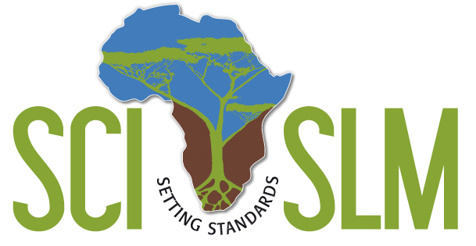 TAG Report 2009/05

SCI-SLM Technical Advisory Group (TAG)

Visit to Morocco

Mission Report: 3 – 7 December 2009

William Critchley and Sabina Di Prima (CIS-VU)

- Introduction
This brief report summarises the main issues covered during the TAG mission to Morocco by William Critchley (WC) and Sabina Di Prima (SDP). The cost of the flights and expenses in Morocco were covered through the SCI-SLM TAG budget. The aims of this mission were to:

- Contribute to the inception meeting and assist the SCI-SLM Morocco team in the formation of the National Steering Committee;
- Provide technical backstopping to the SCI-SLM Morocco team, in particular for (1) pre-identification of potential community initiatives (CIs) through an exploratory mission in one of the two project areas (Bni Idder) and (2) the field testing of methodology;

The detailed schedule of the mission is presented in Annex 1 of this report. It should be noted that the mission to Morocco completed the first round of TAG visits to the four SCI-SLM countries. All the visits were carried out between October and December 2009 as was requested by the project partners during the inception meeting held in South Africa in September.

WC and SDP are grateful to the SCI-SLM Morocco team, in particular Dr. Mohamed Mahdi and Mr Ilias Louah (IL) for their genuine hospitality, availability, commitment and professional input. Despite the limited time available (only three full days), it was possible to achieve the main aims of the mission and establish a solid ground for future collaboration. WC and SDP would also like to thank Dr L. Firdawcy, Vice president of TARGA-Aide, for his guidance and support in setting up the project. Last but not least, a special thank you to Mrs Carmen Lartigue for her linguistic help during the inception meeting and Mr Abdelhay for driving us around safely and welcoming us in his family house for Sunday lunch.

- Inception meeting and discussion with the National Steering Committee (NSC)
The inception meeting took place on Friday 4th December. It had three main objectives: (1) reach a common understanding on the concepts and methodology of the project; (2) establish the NSC; (3) discuss the implementation modalities. The meeting was chaired by Dr L. Firdawcy and attended by fifteen participants from various national organisations/ institutions, namely TARGA-Aide, Haut commissariat des Eaux et Forêts, Cooperation International Sud-Sud (CISS), INRA, etc. The complete list of participants is presented in Annex 2. The opening presentation by Mohammed Mahdi focused on TARGA-Aide’s interest in the SCI-SLM project and the importance of innovations for development. The full text of the presentation is in Annex 3 of this report. Mrs Claire Gerbaud, from the CISS NGO, was invited to present the methodology she developed for the project on best practices in the oasis zones. Then, WC and SDP provided the theoretical underpinning of the project with topical presentations on (i) land degradation, (ii) sustainable land management and (iii) local innovation. They concluded with (iv) an overview of the project and (v) SCI-SLM methodology (field activities and programme development processes). Presentations were alternated with questions and discussions to clarify/ reach common understanding on the key concepts/ aspects of the project. The last presentation was by I.Louah who focused on the selected areas for project implementation.

The inception meeting ended with a focused discussion with the six members of the NSC about the project overall and its implementation modalities. Below are some important points made during the discussion:
- SCI-SLM is not another integrated rural development project. It has a specific focus. It looks at the unexploited innovative potential of communities in the area of SLM;
- It is fundamental to underpin advocacy and upscaling with clear evidence of field-based impacts;
- There is willingness to work in partnership with the national coordination unit (TARGA-Aide);
- There is general support for the project. However, few members still have some skepticism on the role that local innovation by communities can play in the fight against land degradation. The hesitancy is particularly related to the number of community initiatives in SLM that the project will be able to uncover and upscale. According to these NSC members, local community initiatives are not common or easy to find in Morocco;
- In reply to the above point, it was clarified that local innovation by communities is only one possible weapon against the degradation of natural resources. It is not sufficient on its own but it can be very powerful as it is based on the recognition of indigenous knowledge value and the empowerment of people;
- The country targets in terms of number of CIs, number of hectares under SLM, etc are quite low. For instance, each country is expected to select only four CIs during the first two years of the project.
- All members of the NSC expect to receive the project document, the result framework for the country programme and any other relevant information concerning the implementation plan.
Overall, it seems that Morocco has created a very balanced (also genderwise) and competent NSC committed to the successful implementation of the project.

- Field trip: reconnaissance/ pre-identification of community initiatives

SCI-SLM Morocco has decided to focus on two project areas: Ouneine (South) and Bni Idder (North). Given the fact that Ouneine had already been visited by the TAG team in 2003 (mobile workshop) and taking into account the distance factor and time limit, the national coordination unit decided to organise the field visit in the area of Bni Idder. A map of the project area with indication of the provinces covered during the field visits is provided in Annex 4.

A total of five communities were visited during the two days allocated to field visits. The information on the potential CIs visited was gathered mostly from TARGA-Aide staff. In fact, TARGA has been working in this area since 1998. An important lesson learnt during this round of field visits is that preliminary information on potential CIs needs to be cross-checked before embarking on long-distance trips. This is essential given the limited financial and human resources available for the project. In this respect, it was suggested to do some economies of time and funds by either asking one of the implementing partners active in the area to go ahead with pre-identification or piggyback on another mission in the same area to go visit the community. Equally valid is the idea put forward by TARGA to post a staff member of the national coordination unit in the project area for a couple of weeks in order to get better knowledge of the local reality and dynamics. The tables below show the potential CIs already visited and a preliminary assessment of suitability/ eligibility for the project.
No | Community name | Location | Contact/ source of information | Date of visit | Identification team | Type of SLM initiative/ short description | Preliminary assessment
1 | FEDOLIVE/ Rif women Groupement d’Interet Economique (GIE)  (interviewed Mrs Hanane Lachehab) | Chefchaouen province, Northern Morocco | Dr Mohamed Mahdi, TARGA-AIDE | Visited 5/12/09 | MM, IL, WC & SDP | Organic olive oil production | Not suitable: model community initiative already fully developed; received substantial external support & national recognition
2 | Biomass project  (interviewed Mr Salaheddine El Azzouzi) | Bellotta douar, Chefchaouen province, Northern Morocco | Dr Mohamed Mahdi, TARGA-AIDE | Visited 5/12/09 | MM, IL, WC & SDP | Experiment/ trial biomass plot | Not suitable: Research driven on farm trial; no community initiative
3 | Oumnia women agriculture cooperative  (interviewed members of the cooperative) | Bellotta douar, Chefchaouen province, Northern Morocco | Mr Abdelghani Lakhdar, President of the Rif Association for local and sustainable development | Visited 5/12/09 | MM, IL, WC & SDP | Processing of olives for oil production | Not suitable: no innovative social and/ or technical elements uncovered
4 | Bellotta agriculture cooperative  (interviewed members of the cooperative) | Bellotta douar, Chefchaouen province, Northern Morocco | Mr Abdelghani Lakhdar, President of the Rif Association for local and sustainable development | Visited 5/12/09 | MM, IL, WC & SDP | Apiculture | Potentially not suitable: doubts on whether this community initiative has any innovative social and/ or technical elements; it has also received some external support. Very good because keeps young people in their land
5 | Alansar women association for agriculture and rural development  (interviewed several members of the association) | Bni Idder, Northern Morocco | Mr Abdelhay, driver TARGA-AIDE | Visited 6/12/09 | MM, IL, WC & SDP | Cultivation, harvesting and processing of aromatique plants | Not suitable:  no real community initiative (women were grouped together by a professor); no innovative social and/ or technical elements; it has also received some external support; as a general recommendation they should keep better care of their land (eg collection of waste and re-use of material)

Pre-identification 5-6 December 2009: summary of assessment

Eligibility criteria | Communities visited
Eligibility criteria | 1) FEDOLIVE | 2) Biomass project | 3) Oumnia cooperative | 4) Bellotta cooperative | 5) Alansar association
Genuine community (origin) | √ | X | X | √ | X
Technical SLM innovation | √ | X | X | ? | X
Social Innovation | √ | X | X | ? | X
No/ Little outside assistance | X | X | X | X | X
Preliminary assessment | Not suitable | Not suitable | Not suitable | Potentially not suitable | Not suitable
Technical SLM innovation
- Technically effective | √ |  |  | ?
- Economically valid | √ |  |  | ?
- Environmentally friendly | √ |  |  | ?
- Socially acceptable | √ |  |  | ?
Social Innovation
- Sustainable | √ |  |  | ?
- Replicable | √ |  |  | ?
- Inclusive | √ |  |  | ?

Legend: √ = yes; X= no; ? = to be verified

It should be noted that all the initiatives visited during the pre-identification of 5-6 December 2009 are, in principle, good in many aspects. However, they do not conform to the focus of the SCI-SLM project. Thus, they don’t qualify. Detailed information on the first CI visited, FEDOLIVE/ Rif women Groupe d’Intérêt Economique (GIE) can be found in Annex 5: Characterisation form. This is provided as an example of field testing of methodology and formats. The national coordination unit is strongly encouraged to fill in the provided characterisation forms for all the CIs visited (suitable and not suitable) as a form of documentation of the pre-identification phase.

- Meetings with Morocco SCI-SLM team
During its visit, the TAG team worked in close contacts with MM and IL and had the opportunity to hold discussions on a number of issues. The long field trips, in particular, allowed time for thorough discussions on methodology, preliminary assessment of the visited CIs and constructive exchange of ideas on the project.

Below is a list of key points/ suggestions / priorities discussed with the Morocco SCI-SLM team. They are organised in broad clusters.

Practical things:
- Prepare a country-specific results framework in line with the one for the overall project;
- Prepare a work plan and budget for the first year of activities;
- Organise first NSC meeting and have the results framework, work plan and budget approved
- Produce/ update the country briefing note regularly and circulate it to the NSC, partners and all interested/relevant people;
- Receive clear and timely information from CEAD about the content that each country should feed in the website. The website is crucial in order to increase the visibility of the project and involved partners;
- Organise a field visit for the members of the NSC;
- Facilitate the visit of one of the SCI-SLM Morocco team members to the TAG headquarters (CIS-VU) in Amsterdam for in-depth analysis of the identified CIs and sharpening of methodology. This academic visit has been requested by the SCI-SLM Morocco team. It will be covered with the country budget. The exact time of the visit is still to be determined. In any case, it will take place after the identification phase has produced relevant results for analysis.

Methodology:
- SLM is the key technical focus. Therefore, we have to centre our attention only to CIs in SLM. The other areas are important but they are beyond the scope of the project;
- The source of the initiatives can be the creativity/ ingenuity of the community members as well as inspiration got from something seen elsewhere;
- Inventory of initiatives - all the CIs visited, suitable and not suitable for the project, should be documented (also with photos);
- Documentation of identification and selection process and approach is also necessary;
- Use the visitors books of the communities as M&E tool; introduce them where they don’t exist;
- External assistance received disqualifies a community… unless the amount of support received is small (e.g., some training);
- Identification can be up to 10 CIs but after selection the number should become more manageable (approx 4-5); these numbers relate to the initial stages of the project but are bound to increase once the project progress;
- Community members should also be involved in the assessment of their CIs as part of the joint identification team (field agents, researchers/ subject matter specialists and community representatives). The self-assessment is part of the learning process and helps the community understand what they are doing well and what could be improved;
- The overall selection of the CIs to work with (within the project) could be done by the NSC, a representation of the implementing team, the national coordination team and the TAG; such a decision requires overall knowledge and scrutiny of all identified CIs.
- Establish clear and transparent agreements with the communities on what they can and cannot expect from the project;
- Decide the selection criteria and provide adequate justification for them. Criteria can be ranked in order of priority;
- Possible selection criteria to define the “country portfolio of initiatives” could be: mix of social and technical innovations, potential for spread, number of hectares managed sustainably by each community, accessibility in relation to their geographical location, relevance (SLM topics
of national importance that can also contribute to the overall SCI-SLM portfolio), diversification of the portfolio (e.g., CIs related to forest management, water, crops, etc), and reliance on/ involvement of partners; note that this list of possible selection criteria differs from the eligibility criteria on the characterisation forms (see Annex 4);
- Another important criterion for selection is the willingness and suitability of the community. The attitude of the community should favour the process aimed at empowering the community and upscaling;
- Some of the communities that do not qualify for the project are still relevant. They form a second level of communities to be used as good examples (eg FEDOLIVE/ Rif women Groupe d’Intérêt Economique) or to be involved in the outscaling (horizontal spreading) of the selected CIs;
- Favour exchange visits in order to help people expand their horizon and get inspiration. Map how far community members have travelled (monitoring tool). Verify the changes occurred as a result of the exchange visit (before and after);
- South-to-South learning will be mostly based on exchange of principles.

- Conclusion
All in all this was a very intense but extremely productive TAG backstopping mission. The positive attitude and the hard-working nature of the team members made the ambitious programme feasible. This mission sets, undoubtedly, the basis for a promising and constructive collaboration.

Annex 1: Mission Schedule

Date | Persons met | Institutions / Organisation | Main issues
3 Dec | Arrival at Casablanca airport and transfer to Rabat;  Welcomed by Ilias Louah
4 Nov | Inception meeting hosted by TARGA AIDE  - Representatives of TARGA-AIDE and various institutions/ organizations (see attendance list in Annex 2)  Evening: meeting with Dr Mohamed Mahdi |  | - Establishing a common understanding of the project concepts and methodology  - Setting up the National Steering Committee  - Discussion on implementation modalities  - Discussion on inception meeting, field visit, SLM course and potential visit in Amsterdam
5 Nov | Field trip to Bni Idder project area, Chefchaouen province  - Mrs Hanane Lachehab  - Mr Abdelghari Lakhdar  - Mr Salaheddine El Azzouzi  - Members of the women agriculture cooperative Oumnia  - Members of the agriculture cooperative Bellotta | President of the Rif women Groupe d’Intérêt Economique (GIE) and general secretary of FEDOLIVE  President of the Rif Association for local and sustainable development  Coordinator of the biomass project | - Pre-identification of potential community initiatives  - Pre-identification of potential community initiatives  - Pre-identification of potential community initiatives  - Discussion on olive processing for oil production  - Pre-identification of potential community initiatives
6 Nov | Field trip to Bni Idder project area  - Members of the women association for agriculture and rural development Alansar  Visit to TARGA-AIDE gîtes in Bni Idder  Evening: meeting with Dr Mohamed Mahdi and Mr Ilias Louah |  | - Pre-identification of potential community initiatives  - Wrap up meeting: discussion on methodology, priorities for SCI-SLM Morocco, project implementation; next international meeting.
7 Nov | - WC and SDP early departure to Amsterdam

Annex 2: Inception meeting - List of participants

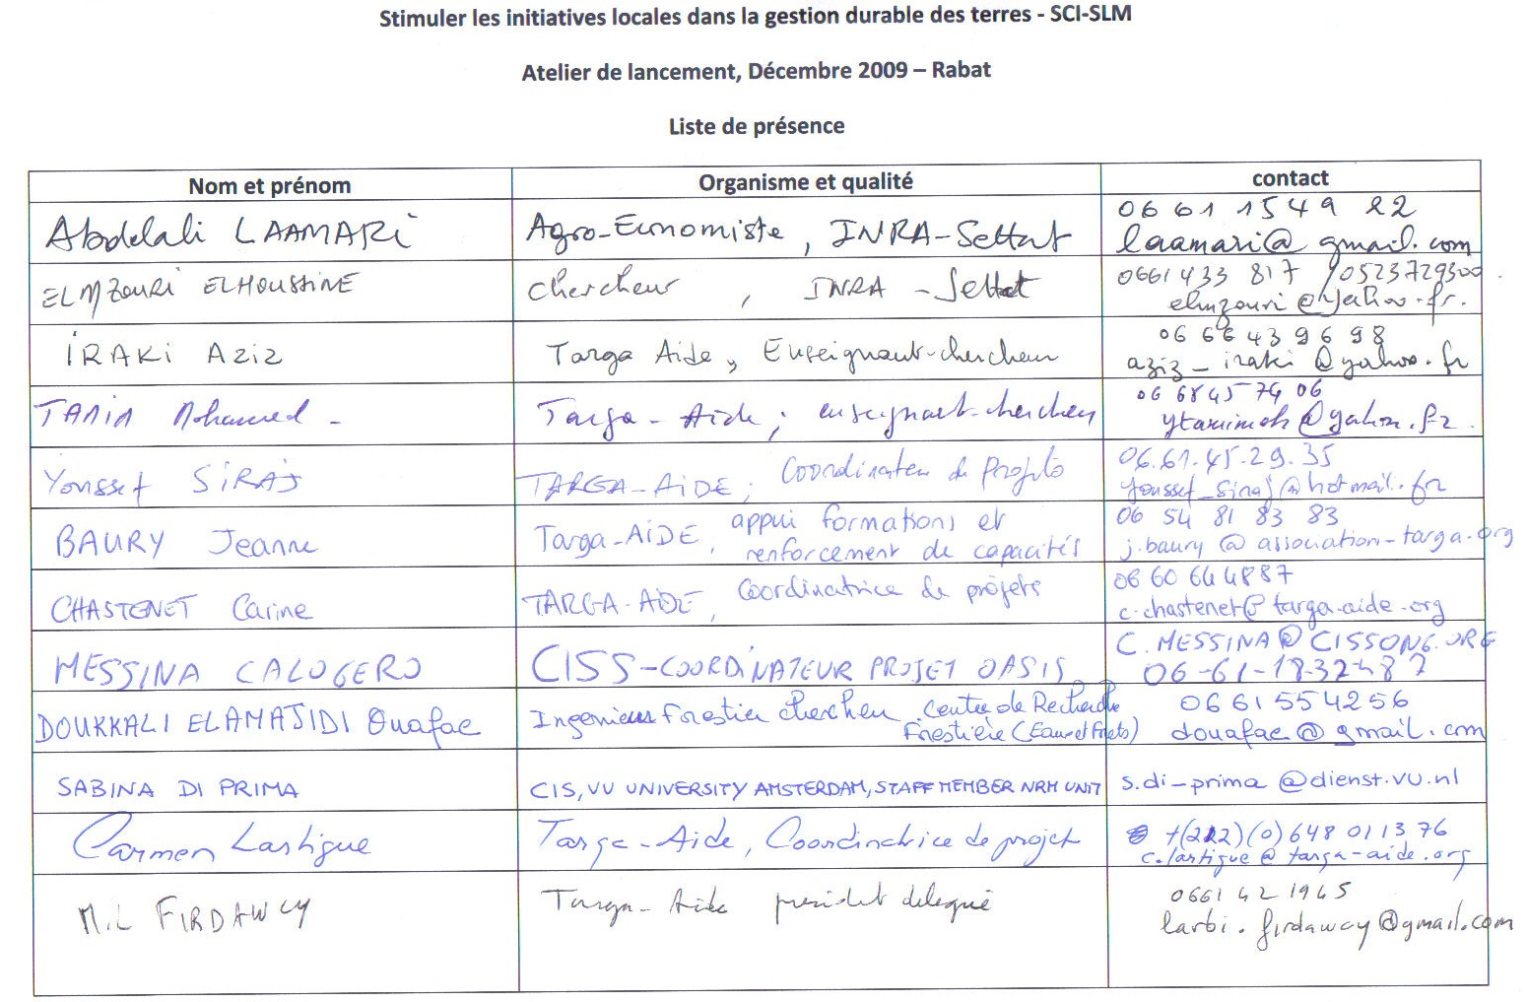
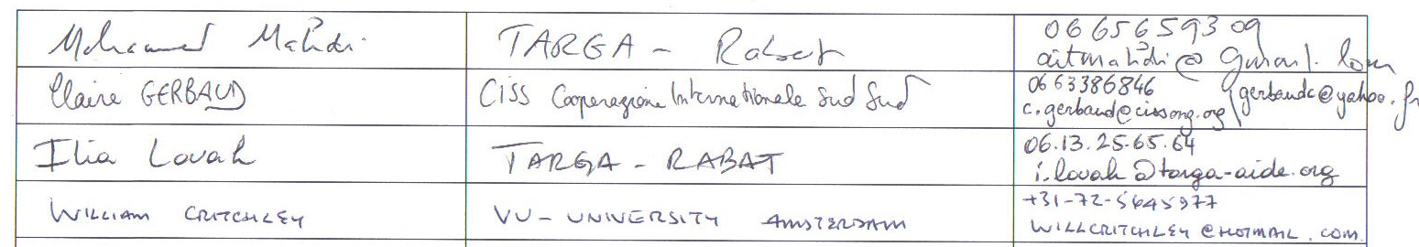
Annex 3: Text Mohammed Mahdi’s presentation

Annex 4: Area covered during field visits

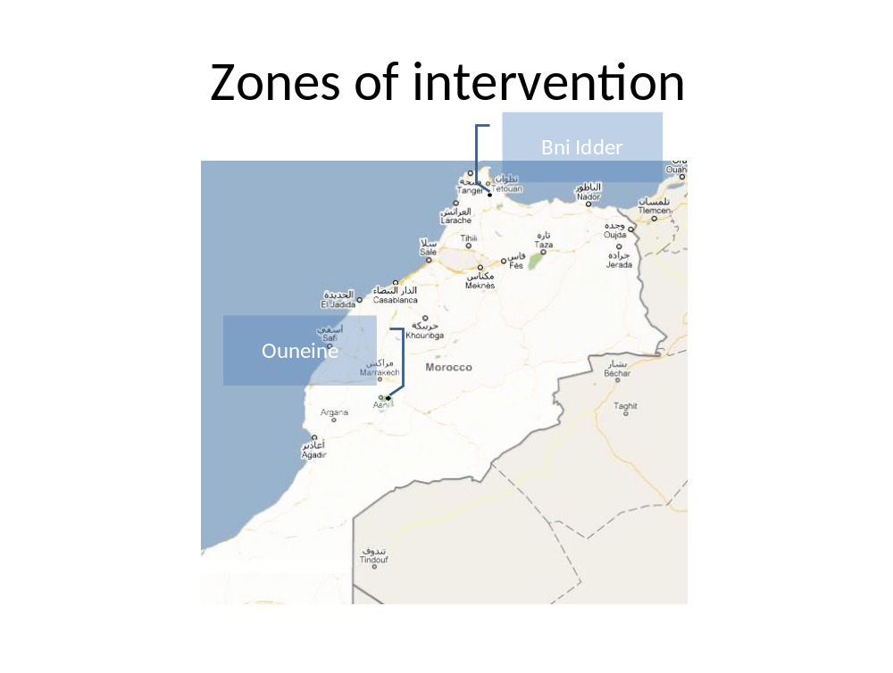
Annex 5: Characterisation form FEDOLIVE/ Rif women Groupe d’Intérêt Economique (GIE)

SCI-SLM Summary Baseline Data Form A

Characteristion of Technical and/or Social Community Initiative/Innovation

Date: 5 December 2009

Team members: Mohamed Mahdi, Ilias Louah, William Critchley and Sabina Di Prima

Interviewee(s): Mrs Hanane Lachehab; President of the Rif women Groupe d’Intérêt Economique (GIE) and general secretary of FEDOLIVE

Name of Community: Rif women Groupe d’Intérêt Economique (GIE) -> GIE Femmes du Rif

Location of Community: Area between Ouazzen and Chefchaouen

Composition of Community: Currently, the GIE comprises 10 cooperatives. The members are 300 women from 6 villages in Chefchaouen province

Technical Initiative/Innovation: Yes. Organic olive oil production related to SLM through improved biodiversity

And / or

Social Initiative/ Innovation: Yes. The organisation of the 10 women cooperatives under the umbrella of the GIE

Eligibility check-list
- Genuine community? Yes

- Their own technical SLM innovation and/or social innovation? In principle both technical and social. However, it needs to be further verified;

- No/ little outside assistance? Received significant external support and recognition

- TEES and/or SRI test compliant? In principle, yes for both

- Suitable and willing community? In principle yes but needs to be verified;

General conclusion: This is a model community initiative already fully developed which it has received substantial external assistance as well as national recognition over the last nine years ( beginning 2001 up to now). Due to the significant help and support received by UNIDO, this community initiative does not qualify for the SCI-SLM project. However, we can envisage involving it in the context of exchange visits and present it as a positive and successful example for other communities.

- Technical SLM innovation

Type: category and brief description Organic/ biological olive oil production.

  - When was it started? What was the trigger for/ motivation behind the innovation?
In order to improve their income, the women of the cooperatives (especially the leaders) thought that it was necessary to make a change in the system of oil production. The idea was to move from a traditional to a more modern system as well as shifting to organic production.

  - Who was the main source of the innovation? The inspiration came from external contacts that some of the members had with professors, technicians and other people specialised in the processing of olives.

  - Is it:
A new idea? New idea with inspiration from outside the community
A modified tradition? ...................................................................
An adapted recommendation? ...................................................
Other? ........................................................................................

  - TEES-test (explain)

Technically effective? In principle yes but needs to be further verified with a
visit in the field. Some information gathered in the preliminary visit: no use of fertilizers; regular analysis of soil samples to guarantee organic production; harvesting of olives is now done by hand and not anymore using sticks; no other change in land management (eg water harvesting or in-field practices).

Economically valid? Yes

Environmentally friendly? In principle, yes but needs to be further verified
with a visit in the field

Socially acceptable? Yes

  - Extra Investments?

Labour? Yes. In the past, during the harvesting season, children didn’t go to school to help in the field. Nowadays, the community receives advance payments from the buyers therefore it can hire paid labourers.

Cash? .........................................................................................

  - Any outside assistance? In 2001, the United Nations Industrial Development Organisation (UNIDO) launched a five year project, funded by the Spanish government, to develop the area between Ouazzen and Chefchaouen. The project aim was to improve the income generated by the olive oil production. UNIDO provided machines and carried out several capacity building activities (eg trainings). The level of support decreased over the five years. In 2006, UNIDO decided to have a second phase to evaluate the project and strengthen the marketing aspects. The second phase started in 2008 and will continue until 2010.

This community initiative has already received national recognition. In 2007, it received three awards of which an international one from FAO. The awards were given for the quality of the oil produced.

  - Benefits realised?

Production? Increased and better quality production; It got already biological certification and tracing label.

Economic? Diversification of income-generating activities related to the processing of olives. Women are busy with processing of olives for oil production from October to December. The other months they produce seasoned olives and cosmetics with olive oil base.

Environmental? To be verified

Social/ cultural? .......................................................................

  - Problems faced?
- Illiteracy of a great number of community members; in the beginning it was not easy working with them.
- Long distances and lack of infrastructure

  - Solutions? Capacity building (eg trainings)

  - Area under SLM in this community initiative? .....................................

  - Spread of innovation? ........................................................................
To how many other communities? ...........................................
Method of spread? .................................................................

  - Current links with extension/ research/ NGOs? UNIDO will be active until 2010

  - Documentation/ monitoring (dates)? To be verified
- Social innovation

  - Type: category and brief description: The organisation of the 10 women
cooperatives under the umbrella of the GIE

  - Associated SLM technology? Organic olive oil production

  - Is the associated SLM technology an innovation? Yes

  - When was the social innovation started? Initially, there were eight agriculture cooperatives working autonomously and not linked to each other. Cooperatives consisted of both man and women. In 2001, the UNIDO project started. UNIDO worked separately with each cooperative providing training and conducting other capacity building activities. In the same year, the composition of the cooperatives changed. They became women cooperatives as a result of the decision made by the female members of the existing cooperatives. They realised that the great bulk of the work done in the process of oil production was carried out by women. Therefore, it was fair for them to fully ripe the benefits of the capacity building programme by UNIDO. It should be noted that the basis for the women cooperative already existed. In fact, women were also organised in groups in relation to other income generating activities (eg cous cous preparation).

In 2003, the women of the cooperatives decided to join all the cooperatives together under the umbrella of the GIE.

  - What was the trigger for/ motivation behind the social innovation? The idea to form the GIE was to strengthen the negotiation power and produce more olive oil.

  - Who was the main source of the social innovation? The female members of the original eight cooperatives.

  - Is it:
A new social arrangement? In principle yes but needs to be further verified
A modified tradition?...................................................................
Other?........................................................................................

  - SRI-test
Sustainable? In principle yes but needs to be further verified
Replicable? In principle yes but needs to be further verified
Inclusive? In principle yes but needs to be further verified

  - Extra Investments?
Labour?......................................................................................
Cash?.........................................................................................
Any outside assistance?............................................................

  - Benefits?
Social/ cultural?.......................................................................
(of the associated SLM measures)

Production?..............................................................................

Economic? Negotiate better price for their produce. Favourable contracts with fixed price (not influenced by the fluctuation on the market) and selling guarantee. They have established a good network of buyers in France, Germany and Dubai. They have entered the more remunerative organic & fair trade niche market.

Environmental?........................................................................

  - Problems faced?
    - Illiteracy of a great number of community members; in the beginning it was not easy working with them.
    - Long distances – the 300 female members are scattered in six villages. The distance in between two villages is on average about 150 km. Despite the distance factor, the community manages to keep constant communication especially through telephone calls but also visits and meetings.

  - Spread of initiative? Through organised visits

To how many other communities? Two women groups have visited and adopted the CI. They are: TAZA and OUJDA

Method of spread?

  - Current links with extension/ research/ NGOs? UNIDO will be active until 2010

Documentation? To be further verified. Students from Rabat, but also France, have visited and studied the CI. Mrs Hanane Lachehab has also taken part in a video that is used as teaching material at the University of Mecnez.

SCI-SLM Summary Baseline Data Form B

Characterisation of Community

Date: 5 December 2009

Team members: Mohamed Mahdi, Ilias Louah, William Critchley and Sabina Di Prima

Name of Community: Rif women Groupe d’Intérêt Economique (GIE) -> GIE Femmes du Rif

Location of Community: Area between Ouazzen and Chefchaouen

Technical Initiative/Innovation (refer to form A) Yes. Organic olive oil production

and/or

Social Initiative/ Innovation (refer to form A) Yes. The organisation of the 10 women cooperatives under the umbrella of the GIE

Details of overall community

  - Type of organisation (village; common interest group etc)

It has the nature of a common interest group: production and marketing of olive oil.

  - Official status? (registered etc)
The Rif women Groupe d’Intérêt Economique (GIE), in French GIE Femmes du Rif, is the legal entity duly registered.

  - Composition of community
Currently, the GIE comprises 10 cooperatives. The members are 300 women from 6 villages in Chefchaouen province

    - Number: 300
    - Male/ female
    - Age structure to be verified

  - Management structure? To be verified.

  - When was it started? In 2003, the women of the cooperatives decided to join all the cooperatives together under the umbrella of the GIE.

  - Was someone local responsible for starting this community organisation? Yes, some of the women, because of their attitude as natural leaders, became the promoters.

  - Was an outside agency responsible for starting this community organisation? No. However, UNIDO facilitated and assisted in the process.

  - Is the community linked to other communities? If so, how?...............

  - Benefits of the initiative to the community?

Production?..............................................................................

Economic? Women have become the main contributors to the family income. They pay for clothes, electricity bills and school fees. Men, even in the very conservative areas, have realised the economic benefits generated by the women’s work and accepted the connected cultural/ social changes.

Environmental?........................................................................

Social/ cultural?
      - Access to an international environment- a big change for women who leave in a very conservative society.
      - In the past, during the harvesting season, children didn’t go to school to help in the field. Nowadays, the community receives advance payments from the buyers therefore it can hire paid labourers. As a result, children can focus on their education.

  - What problems are faced (organisationally or technically or other)?

    - Illiteracy of the community members
    - Long distances – the 300 female members are scattered in six villages. The distance in between two villages is on average about 150 km. Despite the distance factor, the community manages to keep constant communication especially through telephone calls but also visits and meetings.

y. Ambition: The community developed a business plan with the help of UNIDO. In this plan strong attention is given to the social aspects (eg social security for women in the rural areas). The ambition of the community is to successfully implement this business plan.
SCI-SLM Summary Baseline Data Form C

Characterisation of Community Members

Date: 5 December 2009

Team members: Mohamed Mahdi, Ilias Louah, William Critchley and Sabina Di Prima

Name of Community/ Location (refer to form A and B)………………………………..

Details of community member representative of the community

  - Name Mrs Hanane Lachehab; President of the Rif women Groupe d’Intérêt Economique (GIE) and general secretary of FEDOLIVE

  - Address Douar Jabrienne, Caidat BRICHA, Chefchaouen Province

Telehone: 061332760; 071345211

E-mail: fedolive@hotmail.com; femme_rif@hotmail.com

  - Age ………………………………………………………………………..

  - Male/ female

  - Involvement/role in the initiative? President of the Rif women Groupe d’Intérêt Economique (GIE) since its creation and general secretary of FEDOLIVE. Her role as a president and secretary is voluntary/ unpaid

  - Status in family? Married

  - Status in community/ relative resource ownership? ...............................................................................................................

  - When joined the community? ..........................................................

  - Education level? ..........................................................................

  - Main occupation? .............................................................................

  - Current benefits of the community initiative to this individual?

Production? ..............................................................................

Economic? ................................................................................

Land under SLM (ha)? ……………………………………………..

Other? ........................................................................................

